Business Models and Methods in HRM
Student's Name
Institutional Affiliations
Date of Submission

Business Models and Methods In HRM
Business models and methods are the developed paths through which a company walks. They offer ways in which things should be done. Well established business models help a company in acquiring value in economic, social, cultural, and other concepts areas. It is through these works of art that a company can know what problems it faces and how to deal with them. The human resource management department, for example, faces diverse problems to solve from balancing employees and management relationships, training and development, recruitment to performance appraisal. To work on these problems, this department inevitably adopts several business models and methods in its activities. Several models have proved functional to the human resource managers, including the standard casual model, the eight-box model by Paul Bosele, the HR value chain, and the Harvard framework for HR (Eisenstat, 1996).
The Standard casual model
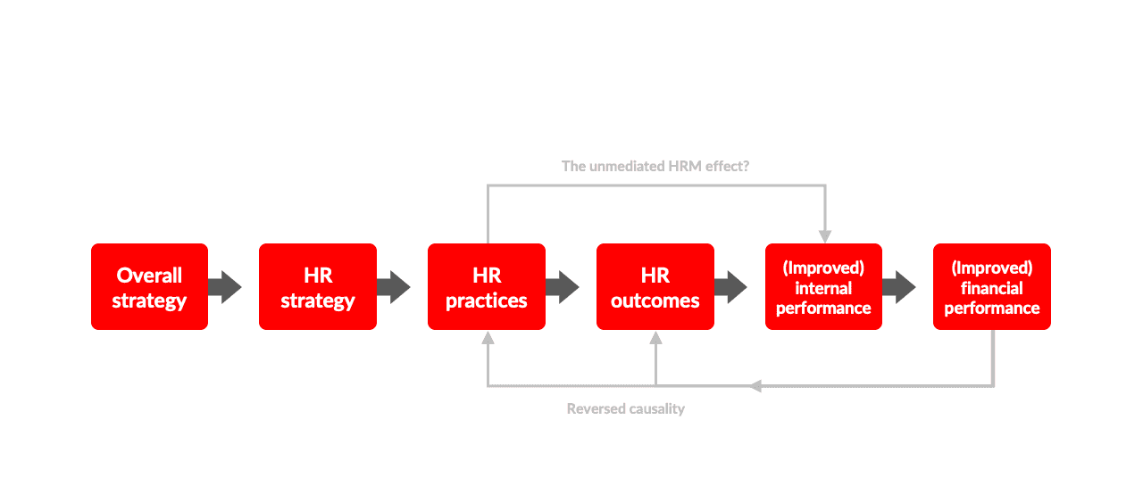
This model stipulates how HRM strategies affect the general performance of the business and how the business strategies to affect HRM performance. From Eisenstat (1996), the standard casual model champions for alignment of both approaches. This is what will propagate success in areas such as productivity and quality. Some activities of the HRM directly affect the internal performance of a business; for example, if the department ensures practical training of employees, there is a possibility that there will be an improvement in performance.
The eight-box model
The eight-box model shows how different environments may have an impact on the general performance of the HRM. The extreme environments in this sector being Internal and External. Whatever goes on either in or out of business has a huge implication in the HRM department. For example, if there is an adverse shortage of a specific group of experts, this would change the recruitment criteria used by the HRM. The model focuses on the activities of HR as intended and as implemented. It, therefore, shows HR's planned actions, HR actual activities, HR perceived events, and, eventually, the HR outcomes (Eisenstat, 1996). The outcomes are the results of what has been done. All these are affected by whatever is going on either outside the business or inside.
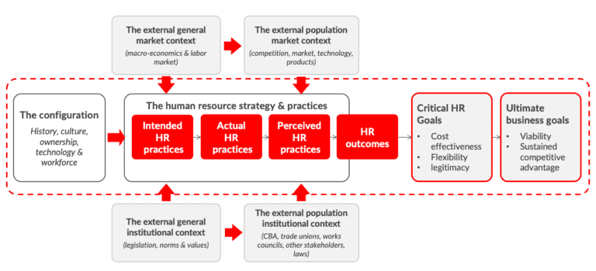

The HR value chain
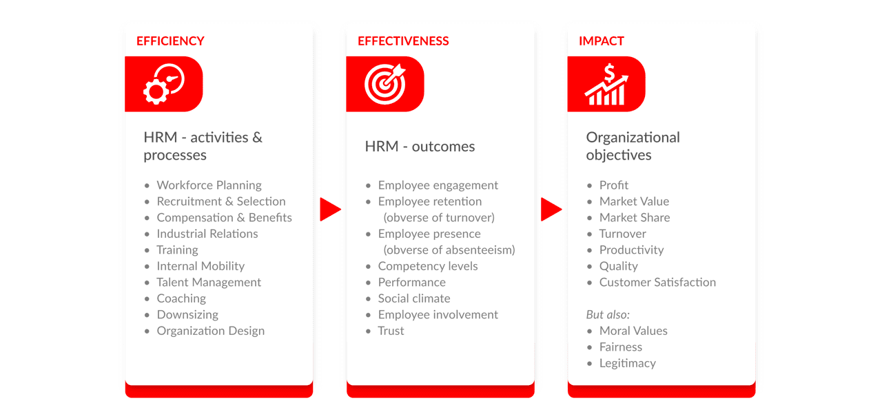
This is one of the most known models and methods in HR history. It breaks the entire operations of the HRM into two; HRM activities and HRM outcomes. It states that the HR activities are the day to day doings of the department, while HRM outcomes are the set goals that the department works towards (Budhwar and Khatri, 2001). The model further states that a company should pay more attention to HRM outcomes rather than activities. For example, if company A wanted to hire a storekeeper, they should spend more time and resources in recruiting the most qualified person, rather than doing it quickly and taking the least expensive. The model also reveals the impact of these factors on the general business.
The Harvard framework for HRM
It is made up of six factors; The stakeholder's interest by which the guidelines of HRM build, situational aspects affecting their operations, HRM strategies, HRM results (Bailey, et al., 2018).
Long term consequences on the business. It takes a more comprehensive and generally more detailed overview of the HRM.
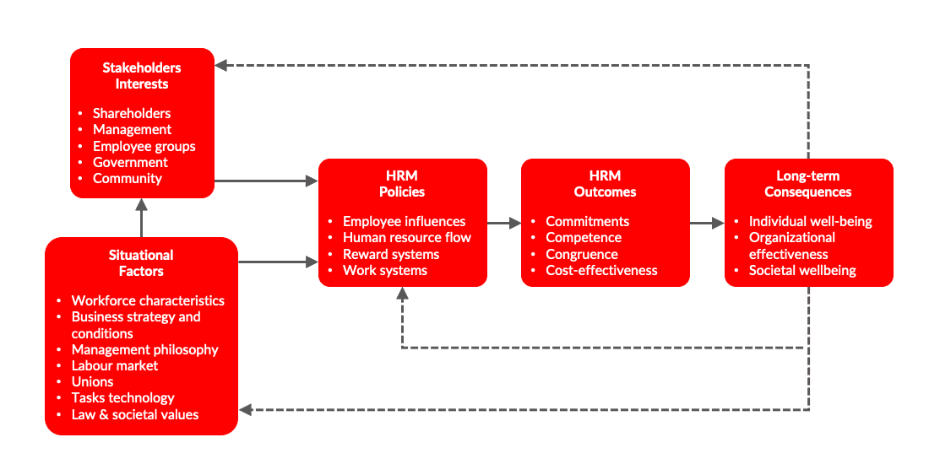

The HR value chain advanced
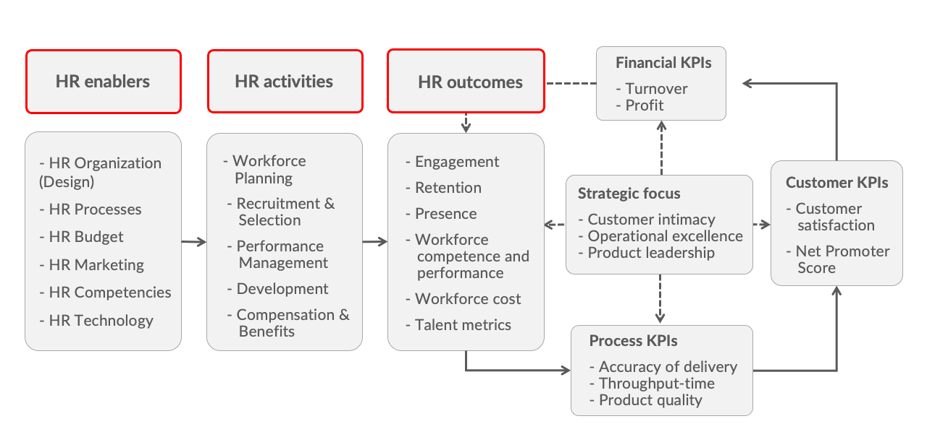
Defines that balanced HR scorecards and the enablers influence the outcomes of HR.
Short reflective paper
I have realized that management is a complex activity that may call upon everyone in the organization to be able to foster success. The HR department is not exempted. It faces problems that are so complex beyond what they can realize or handle by merely acting. This is the reason why models are to be employed in their basic operations (Bailey, et al., 2018).
.

References
Bailey, C., Mankin, D., Kelliher, C., & Garavan, T. (2018). Strategic human resource management. Oxford University Press.
Budhwar, P. S., & Khatri, N. (2001). HRM in context: Applicability of HRM models in India. International Journal of Cross-Cultural Management, 1(3), 333-356.
Eisenstat, R. A. (1996). What corporate human resources bring to the picnic: four models for functional management. Organizational Dynamics, 25(2), 7-22.

